News & Media APIs

📰 What Are News & Media APIs?
# Source: AI Source: Provided by: [Data Path: Persons Table -> ID Column: 1, Name_En Column: Motasem Essam] -> From: [Chatgpt (GPT‑5 Mini)] on [1/19/2026]
News & Media APIs are web service interfaces that provide access to news articles, headlines, media content, metadata, and publisher information from various sources. These APIs allow developers to build apps that deliver real-time news, search topics, track trends, or aggregate content from multiple media outlets.

✅ What News & Media APIs Can Do
# Source: AI Source: Provided by: [Data Path: Persons Table -> ID Column: 1, Name_En Column: Motasem Essam] -> From: [Chatgpt (GPT‑5 Mini)] on [1/19/2026]
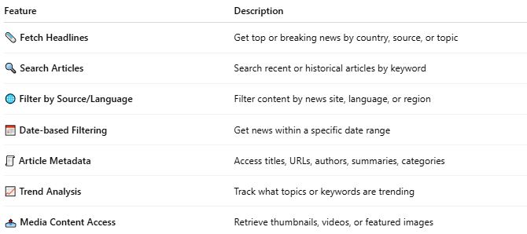

Feature | Description
🗞️ Fetch Headlines | Get top or breaking news by country, source, or topic
🔍 Search Articles | Search recent or historical articles by keyword
🌐 Filter by Source/Language | Filter content by news site, language, or region
📅 Date-based Filtering | Get news within a specific date range
🧾 Article Metadata | Access titles, URLs, authors, summaries, categories
📈 Trend Analysis | Track what topics or keywords are trending
📤 Media Content Access | Retrieve thumbnails, videos, or featured images

🧩 Popular News & Media APIs
# Source: AI Source: Provided by: [Data Path: Persons Table -> ID Column: 1, Name_En Column: Motasem Essam] -> From: [Chatgpt (GPT‑5 Mini)] on [1/19/2026]
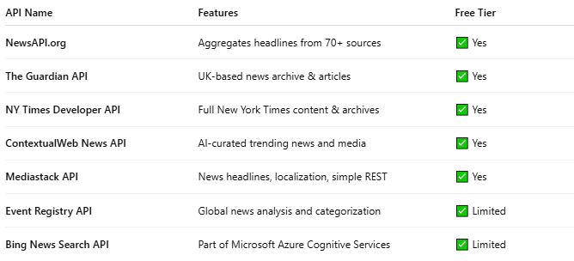

API Name | Features | Free Tier
NewsAPI.org | Aggregates headlines from 70+ sources | ✅ Yes
The Guardian API | UK-based news archive & articles | ✅ Yes
NY Times Developer API | Full New York Times content & archives | ✅ Yes
ContextualWeb News API | AI-curated trending news and media | ✅ Yes
Mediastack API | News headlines, localization, simple REST | ✅ Yes
Event Registry API | Global news analysis and categorization | ✅ Limited
Bing News Search API | Part of Microsoft Azure Cognitive Services | ✅ Limited

📤 Example: NewsAPI.org (Get Top Headlines)
# Source: AI Source: Provided by: [Data Path: Persons Table -> ID Column: 1, Name_En Column: Motasem Essam] -> From: [Chatgpt (GPT‑5 Mini)] on [1/19/2026]
Request:
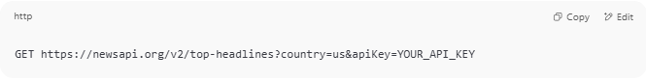
GET https://newsapi.org/v2/top-headlines?country=us&apiKey=YOUR_API_KEY

Response:
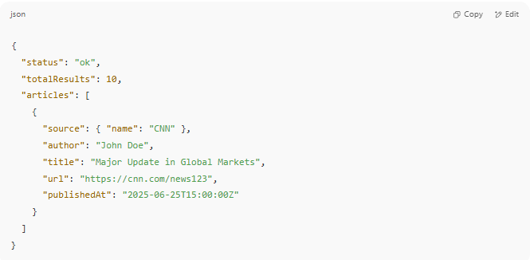
{
"status": "ok",
"totalResults": 10,
"articles": [
{
"source": { "name": "CNN" },
"author": "John Doe",
"title": "Major Update in Global Markets",
"url": "https://cnn.com/news123",
"publishedAt": "2025-06-25T15:00:00Z"
}
]
}

📅 Use Cases
# Source: AI Source: Provided by: [Data Path: Persons Table -> ID Column: 1, Name_En Column: Motasem Essam] -> From: [Chatgpt (GPT‑5 Mini)] on [1/19/2026]
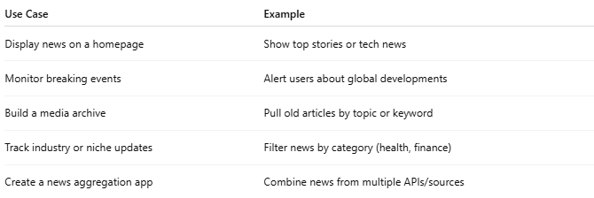

Use Case | Example
Display news on a homepage | Show top stories or tech news
Monitor breaking events | Alert users about global developments
Build a media archive | Pull old articles by topic or keyword
Track industry or niche updates | Filter news by category (health, finance)
Create a news aggregation app | Combine news from multiple APIs/sources

🔐 Authentication & Limits
# Source: AI Source: Provided by: [Data Path: Persons Table -> ID Column: 1, Name_En Column: Motasem Essam] -> From: [Chatgpt (GPT‑5 Mini)] on [1/19/2026]
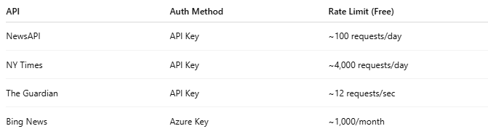
API | Auth Method | Rate Limit (Free)
NewsAPI | API Key | ~100 requests/day
NY Times | API Key | ~4,000 requests/day
The Guardian | API Key | ~12 requests/sec
Bing News | Azure Key | ~1,000/month

